
UNEMPLOYMENT RISK MANAGEMENT PROGRAM
FREE ANALYSIS

501(c)3 nonprofit agencies with 15+ full-time employees may qualify for Trust membership. To determine if 501(c) Agencies Trust can save your agency time and money on unemployment costs, please fax this completed form to (800) 449-8563.

Questions? Call us at (800) 631-2967 or visit us online at 501cTrust.org.

Agency Name ____________________________________________________
CONTACT
INFORMATION
Contact _________________________________________________________
Title ____________________________________________________________
City ______________________________________ State _________________
Telephone _______________________________________________________
E-mail __________________________________________________________

Total Gross Annual Payroll (Last 4 Quarters) ________________________
PAYROLL HISTORY
Total SUI Taxable Payroll (Last 4 Quarters) _________________________

Pay UI Taxes through the state ID # ________________________
CURRENT
UNEMPLOYMENT
PROGRAM METHOD
(Check one)
Current UI tax rate ____________________%
Attach your current tax rate or contribution notice form.

Reimburse the state

2016 $_________________
UNEMPLOYMENT
BENEFITS HISTORY
Total amount paid in claims
2015 $_________________
2014 $_________________
Are you anticipating any funding changes or layoffs over the next 25 months?
No Yes Explanation _________________________________________
________________________________________________________________

Signature ________________________________________________________
Title ____________________________________________________________

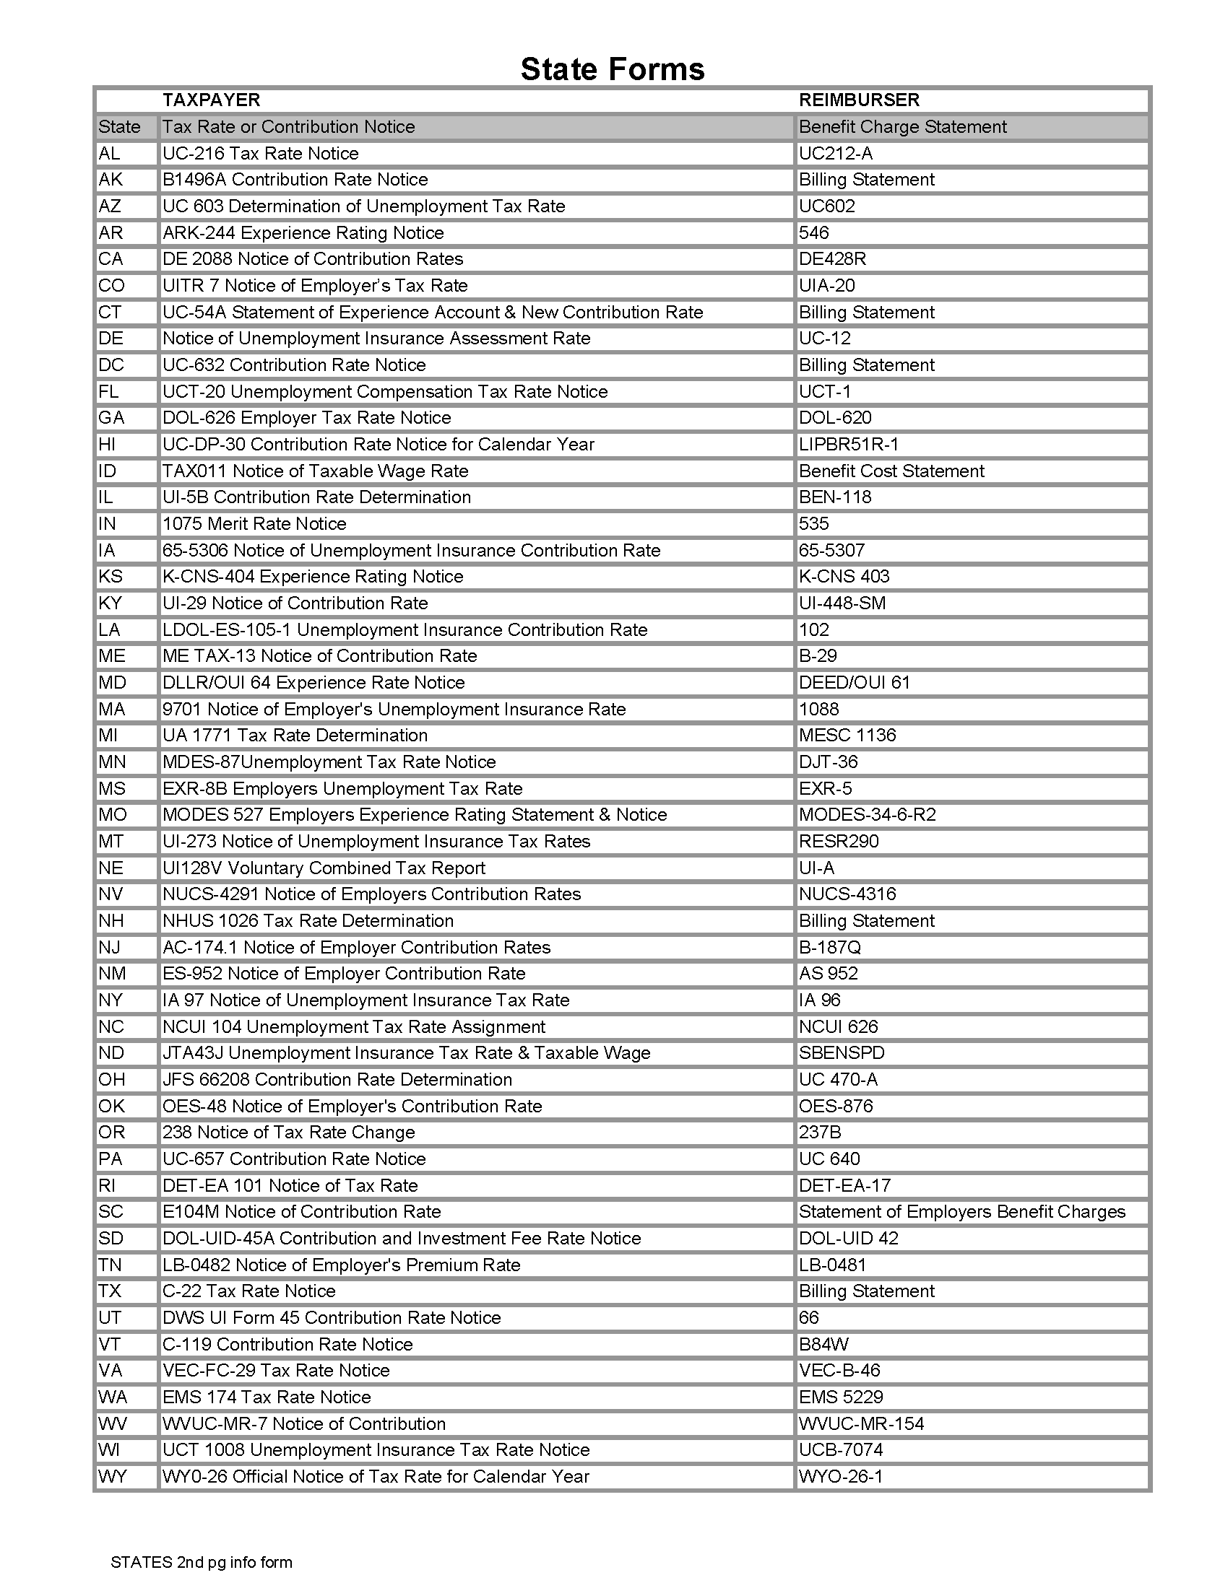
Total SUI Taxable Payroll (Last 4 Quarters):

